Stakeholder Consultation Report

PUBLICATION DATE 14.10.2020
VERSION v. 1.1
RELATED SUPPORT

- TEMPLATE GUIDE Stakeholder Consultation Report v. 1.1

This document contains the following Sections
Key Project Information
SECTION A - Information made available to Stakeholders
SECTION B - Invitations made to Stakeholders
SECTION C - Report of the Consultation Process
SECTION D - Continuous input / Grievance mechanism
SECTION E – Stakeholder Feedback Round

KEY PROJECT INFORMATION
GS ID of Project | 11544
Title of Project | Maji Safi, Maisha Bora Project
Version number of the SCR | 1.2
Completion date of version | 06/04/2022
Time of First Submission Date | 07/04/2022
Start Date of the Project | 01/07/2022
Date of Meeting (s) | 24/01/2022
Project Cycle: | Regular  Retroactive

INFORMATION MADE AVAILABLE TO STAKEHOLDERS
        - A non–technical summary of the project
>>
OffgridSun, in collaboration with Makohaa and Epicenter Africa; is implementing Maji Safi, Maisha Bora Project in Siaya County, located in Western Kenya in the Victoria Lake region.

Main objective of the project is to improve the livelihoods of about 25.000 people living in Uhanya and Usenge villages, with no safe water access schemes in place. By providing sufficient, affordable, and clean drinking water to targeted communities within reasonable proximity and using purification technologies that are safe for the environment, the project aims to reduce the carbon emissions.

Recent data from regional authorities shows that only 42% of the population have access to water from improved sources in Siaya County. Most of the population draws water from open sources such as the lake, dams & open pans are in need of clean water access. The water drawn from open sources is either consumed untreated or is treated by boiling, where firewood is the main source of energy. The project aims to reduce greenhouse gas emissions from boiling unsafe water by introducing zero- emission technologies for water purification.
Maji Safi, Maisha Bora! (Clean Water, Better Life!) Project will install water treatment systems (purification system, water storage, water kiosks) in Usenge and Uhanya villages. Solar powered water treatment systems will be used in both villages. For this purpose, the following activities will be carried out;
- Site identification on Lake Victoria shore of the proper place for treatment system allocation
- Installation of Sedimentation, Alum & Chlorination System & solar powered lift pump
- Pipeline construction from treatment system to water storage and to water kiosks
- Construction of water tower, installation of tank for water storage & fencing
- Construction of water kiosks & fencing
- Installation of remote monitoring control system

The project will positively impact on the environment since the greenhouse gas emissions derived from boiling unsafe drinking water will be reduced by making safe water accessible to local population through the establishment of solar powered community-level water treatment technologies (CWT) and community-level water supply technology (CWS).
Timeline:
The installation of water treatment systems (purification system, water storage, water kiosks) in both Usenge and Uhanya villages are planned to start in May 2022.

Step | Time
PROJECT TIMELINE
Conducting Stakeholder Engagement Meeting | Jan, 24th 2022
Data collection for baseline survey | Feb. – March 2022
Installation of water treatment systems (purification system, water storage, water kiosks) in Usenge and Uhanya villages | May-June 2022
Water system commissioning and start of operation | July 2022

        - Contact details to get further technical detail and project information
>>
Organization | Role | Responsible Person | Contact Details
Offgridsun | Project Proponent, Italy | Valentina Quaranta | v.quaranta@offgridsun.org
Makohaa | Project Proponent, Kenya | Orodi Odhiambo | orodiodhiambo@yahoo.com
Epicenter Africa | Project Proponent, Kenya | Mary Njue | mary.njue@epicenterafricaengineering.com
Genius Watter | Project Proponent, Italy | Dario Traverso | d.traverso@geniuswatter.com
Pile Ngima Women Association | Project Proponent, Kenya | Noah Albert | albertnoah1972@gmail.com
Ceres Env. Eng. | Carbon Consultant, Turkey | Zeynep Pinar Ozturk | pinar.ozturk@ceres-tr.com

        - Summary of economic, social and environmental impacts of the Project
>>
Environmental impacts | 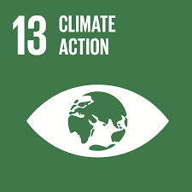 | Reduction of CO2 emissions:  By establishing solar powered community-level water treatment technologies (CWT) and community-level water supply technology (CWS), the project will make safe water accessible to local population and will reduce GHGs emissions from boiling unsafe water. Since solar powered water treatment systems will be used, no GHG emissions will be released during water purification process.
 | 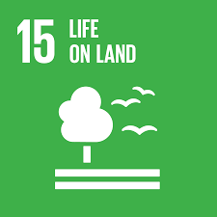 | Reduced deforestation:  Firewood is the main source of energy for boiling the untreated water. Most of the rural households depend on the forest for their biomass need, causing deforestation at high rates. When accessing safe water, there will be no need to boil unsafe water.  This will have positive impact on forest degradation and deforestation related to firewood consumption for boiling purposes in the region.

Social impacts | 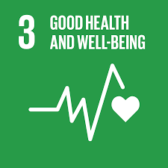 | Improved health conditions:  Population in the project region do not have access to safe drinking water within reasonable reach. The water resources are prone to contamination exposing the community to water borne diseases.  Furthermore, household members using cook stoves suffer burns during boiling the unsafe water.  Accessing safe water will protect the community from water borne diseases and lessen burns during the water boiling activities.
 | 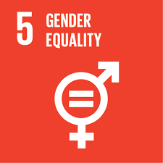 | Empowerment of women:  Health conditions associated with water boiling activities will be improved particularly for women and young girls with implementation of the project.  Saving the time spent for boiling water and firewood collection, women will have more time available for leisure, education or opportunities for market employment that can raise their household status.
 | 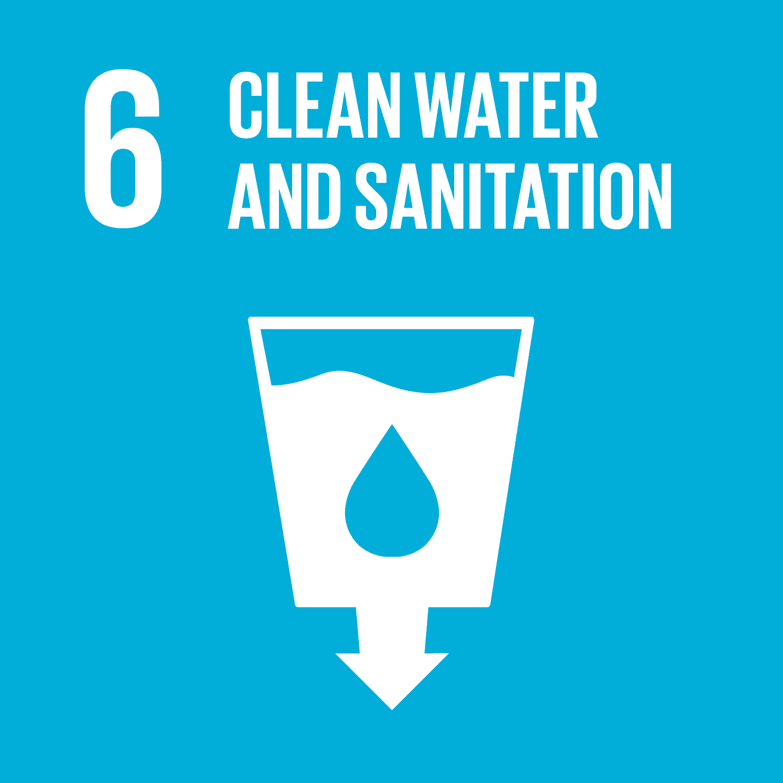 | Access to safe water:  The project aims to provide access to safe water at least 25,000 people. WASH trainings regarding water use, health and hygiene and will be held among the communities in parallel to the project implementation.

Economic Impacts | 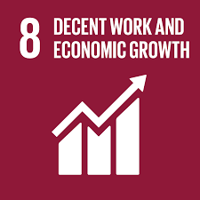 | Creating jobs:  Installation of the water treatment systems (purification system, water storage, water kiosks), and maintenance activities will create temporary and permanent job opportunities for local people. Drinking water will be sold to private users and shops at accessible prices by local water vendors that are mainly women. This will create job opportunities for the community.

        - Other relevant information to help stakeholders understand the project
>>

INVITATIONS MADE TO STAKEHOLDERS
        - Invitation tracking table
Please complete the table below
Category Code | Stakeholder Type/Organisation (if relevant) | Name of invitee | Male/  Female | Method of invitation | Date of invitation  (>30 days before Meeting)
A | Local community | General public | N/A | Newspaper ad | 23/12/2021
A | Community Health Worker | Sara Nyaoke | F | Invitation Letter | 17/12/2021
A | Community Health Worker | Juliana Sandala | F | Invitation Letter | 17/12/2021
A | Community Health Worker | Demitila Adhiambo Otieno | F | Invitation Letter | 17/12/2021
A | Community Health Worker | Prisca Agwari | F | Invitation Letter | 17/12/2021
A | Community Health Worker | Rael Ochieng | F | Invitation Letter | 17/12/2021
A | Village Chief | Charles Odhiambo Okello | M | Invitation Letter | 17/12/2021
A | Village Chief | John Omenya Atito |  | Invitation Letter | 17/12/2021
A | Village Chief | James Otieno | M | Invitation Letter | 17/12/2021
A | Village Chief | Johana Oliudoh | F | Invitation Letter | 17/12/2021
A | Village Chief | Paul Owiti | M | Invitation Letter | 17/12/2021
A | Village Chief | Jacob Misoga |  | Invitation Letter | 17/12/2021
A | Village Chief | Pamela Atieno Mdolo | F | Invitation Letter | 17/12/2021
A | Village Chief | Zedekia Onyango Nyajere | M | Invitation Letter | 17/12/2021
A | Village Chief | George Rakwel | M | Invitation Letter | 17/12/2021
A | Village Chief | Gaddy Otieno Onyango | M | Invitation Letter | 17/12/2021
A | Village Chief | Paul Aremo | M | Invitation Letter | 17/12/2021
A | Village Chief | Jennifer Otieno | F | Invitation Letter | 17/12/2021
A | Village Chief | Jackson Domor Oklino | M | Invitation Letter | 17/12/2021
A | Village Chief | Lazaro Oglire Orewe | M | Invitation Letter | 17/12/2021
A | Village Chief | Millicent Okiello | F | Invitation Letter | 17/12/2021
A | Village Chief | James Oracho Wire | M | Invitation Letter | 17/12/2021
A | Village Chief | Owino Steven | M | Invitation Letter | 17/12/2021
A | Village Chief | James Wire Obola | M | Invitation Letter | 17/12/2021
A | Village Chief | Isaac Otiano | M | Invitation Letter | 17/12/2021
A | Village Member | Orunda Joseph | M | Invitation Letter | 17/12/2021
A | Village Member | Willis Odhiambo | M | Invitation Letter | 17/12/2021
A | Youth Representative | Alfred Mtojira | M | Invitation Letter | 17/12/2021
A | Youth Representative | Catherina Maganda | F | Invitation Letter | 17/12/2021
A | Youth Representative | Denis Otielo Owhok | M | Invitation Letter | 17/12/2021
A | Representative of Anyanga Beach | Erick Omondi Nyachod | M | Invitation Letter | 17/12/2021
C | Public Health Officer Yimbo Ward | Eveline Wesonda | F | Invitation Letter | 17/12/2021
C | Water officer Sub County Bondo | Moses Ondiji | M | Invitation Letter | 17/12/2021
C | Director of Water Siaya County | Henry Juma | M | Invitation Letter | 17/12/2021
C | County Assembly, Representative of Yimbo Ward | Willis Okoth | M | Invitation Letter | 17/12/2021
C | Ministry of Energy | General | N/A | info@energy.go.ke | 22/12/2021
C | Ministry of Environment and Forestry | General | N/A | psoffice@environment.go.ke | 22/12/2021
C | Ministry of Water, Sanitation and Irrigation | General | N/A | ps@water.go.ke | 22/12/2021
C | Ministry of Health | General | N/A | ps@health.go.ke | 22/12/2021
C | Ministry of Public Service and Gender, State Department for Gender | General | N/A | info@gender.go.ke | 22/12/2021
C | Ministry of Agriculture | Dr. Alice Ruto | N/A | arutoc@gmail.com | 22/12/2021
C | World Bank Kenya | General | N/A | Kenyainfo@worldbank.org | 22/12/2021
C | World Bank Kenya | Mr. Peter Warutere | Male | pwarutere@worldbank.org | 22/12/2021
C | GIZ | General | N/A | giz-kenia@giz.de | 22/12/2021
C | USAID | General | N/A | usaidkea@usaid.gov | 22/12/2021
C | Community Development Trust Fund (CDTF) | Mr. Kiprono Shadrack | Male | skiprono@cdtfkenya.org | 22/12/2021
C | Women Development Centre (WODEC) EA LTD | Ms. Milka Cherotich | Female | womendevelopmentcenter@yahoo.com | 22/12/2021
D | National Environment Management Authority | Anne Nyatichi Omambia, Climate Change Desk Officer | Female | anomambia@nema.go.ke; anomambia2002@yahoo.co.uk | 22/12/2021
D | National Environment Management Authority | Mamo Boru Mamo, Director General | Male | dgnema@nema.go.ke; mmamo@nema.go.ke | 22/12/2021
E | Jumuiya Women Fund (JWF) | Ms. Milkah Cherotich | Female | ceo@jumuiyawomenfund.org | 22/12/2021
E | 42 Plus Foundation | Mrs. Stella Sigana | Female | 42plusfoundation@gmail.com | 22/12/2021
E | Action for Research and Development (AFORD) | Mr. Isaac Gogo | Male | igogo@aford.or.ke | 22/12/2021
E | Africa Center for Health Systems Research & Management (ACHESREM) | Mr. Vitalis Akora | Male | info@climatechange-hub.org | 22/12/2021
E | African Christians Organization Network | Mr. Salim Mayeki Shaban | Male | africanchristiansorganizationn@gmail.com | 22/12/2021
E | Better Family Life Trust | Ms. Josephine Muhonja Elizabeth | Female | betterfamilylifetrust@gmail.com | 22/12/2021
E | Bioenergy Research And Development Foundation (Biforad) | Dr. Joseph Lelon | Male | director@biforad.org | 22/12/2021
E | Community Servants | Mr. Stanley Ndung'u | Male | community.servants@yahoo.com | 22/12/2021
E | Daho | Mr. George Arango | Male | amuaafricaproject@gmail.com | 22/12/2021
E | Dandora Youth Initiative | Mr. Peter Kamau Kariuki | Male | dandorayouthinitiative011@yahoo.com | 22/12/2021
E | ecoprenuers for climat-nairobi lab. | Mr. Sylvester Woga | Male | impactcommunication04@gmail.com | 22/12/2021
E | Global Solutions and Environment Protection | Josephine Samuel | Female | jomukenya@gmail.com | 22/12/2021
E | Icuga Womens Health Organization | Mrs. Jeniffer Iregi | Female | enifferiregi@gmail.com | 22/12/2021
E | Kenya Association for Maternal & Neonatal Health -KAMANEH | Mr. Richard Karori | Male | kamanehk@gmail.com | 22/12/2021
E | Nalepo Conservation Programme | Mr. Francis Rramet | Male | nalepoprogramme@yahoo.com | 22/12/2021
E | PCEA Eastleigh Community Centre | Mr. Phares Nyaga | Male | pceaecc@africaonline.co.ke | 22/12/2021
E | Population Services Kenya | Mr. Anthony Okoth | Male | aokoth@pskenya.org | 22/12/2021
E | Practical Action Eastern Africa | Ms. Yolanda Weldering | Female | yolanda.weldring@practicalaction.org.uk | 22/12/2021
E | Safe Water and AIDS Project | Ms. Alie Eleveld | Female | alie@swapkenya.org | 22/12/2021
E | Support Initiative for Health, Education, and Development - Shedi Kenya | Mr. Silvanus Odede | Male | ajeysilvans@gmail.com | 22/12/2021
E | Sustainable Development For All | Mr. Kennedy Akunda | Male | info@sdfa-kenya.org | 22/12/2021
E | Sustainable Integrated Landscape Development Organization (SIDO) | Mr. Fabian Musila | Male | fmusila@hotmail.com | 22/12/2021
E | Visionary Empowerment Programme | Mr. Bernard Ndungu | Male | bndungu@vep.co.ke | 22/12/2021
E | Young Volunteers for the Environment, Kenya Chapter | Ms. Caroline Cosilei | Female | CarolCosilei@gmail.com | 22/12/2021
E | African Entrepreneurial Network Ltd | Mr. Vincent Rapando | Male | vrapando@aenafrica.com | 22/12/2021
E | Chuodho Women Group | Mr. John Okeyo | Male | rularede2002@yahoo.com | 22/12/2021
E | Community Action For Health And Development | Ms. Rael Achieng | Female | cahedchildrenrescure@gmail.com | 22/12/2021
E | Diocese of Kitui-Caritas kitui | Mrs. Florence Ndeti | Female | fndeti@caritaskitui.org | 22/12/2021
E | Kiangure Springs Environment Initiative | Mr. Joram Mathenge | Male | kiangurespringsenvipro@gmail.com | 22/12/2021
E | Ngando Universal Centre | Ms. Susan Kanguha | Female | ngandounice@yahoo.com | 22/12/2021
E | Tree Is Life Trust | Mr. Thomas Gichuru | Male | thomaina05@gmail.com | 22/12/2021
E | African Centre For Technology Studies | Mr. Kiprono Kirui S | Male | s.kirui@acts.or.ke | 22/12/2021
E | Abha Light Foundation | Dr. Didi AnandaRuchira | Male | info@abhalight.org | 22/12/2021
E | Africa Center for Energy and Environment Solutions | Ms. Esther Were | Female | esther.were@acees.org | 22/12/2021
E | Arero Women Group | Ms. EDITH WAIRIMU | Female | edopet09@gmail.com | 22/12/2021
E | Bidhaa Sasa | Rocio Perez Ochoa | Male | rocio.perez-ochoa@bidhaa.co.uk | 22/12/2021
E | Consumer's Choice Limited | Mr. Mohammed Kadhi | Male | cclmotosafi@gmail.com | 22/12/2021
E | Neonet Services | Mr. Omboga George | Male | moirongobwomboga@yahoo.com | 22/12/2021
E | NewLight Africa | Mr. Steve Andrews | Male | steve.andrews@newlightafrica.com | 22/12/2021
E | Raybridge Ltd | Mr. Raychelle Injete | Male | raychelle@raybridge.co.ke | 22/12/2021
E | Stamp Cleantech Td | Mr. Keneth Mitambo | Male | keneth.ndua@gmail.com | 22/12/2021
F | Gold Standard representative | help@goldstandard.org | N/A | Email | 22/12/2021
G | United Purpose | Lloyd Archer | Male | lloyd.archer@united-purpose.org | 22/12/2021
G | Global Offset Research | Siddharth Yadav | Male | syadav@globaloffsetresearch.com | 22/12/2021
G | CEDESOL | David Whitfield | Male | david@cedesol.org | 22/12/2021
G | Lean Management Systems Promotion Society | Raave Jain | Male | lmpsindore@gmail.com | 22/12/2021
G | HIVOS | Harry Clemens | Male | hclemens@hivos.org | 22/12/2021
G | NOVA | Montagu Murray | Male | montagumurray@nova.org.za | 22/12/2021

          - Appropriateness of methods
>>
Category A: The project targets to the communities in Yimbo region. An advert of the meeting was published in local newspaper on 23/12/2021 to invite all interested local communities. The local community leaders also were invited by invitation letters on 17/12/2021. Please see Annex.1 for a sample of Invitation Letter.

Category B: There are no stakeholders whose land-tenure rights will be affected by the implementation of the project.

Category C: Local policy makers and representative of local authorities related with the project (Category C) invited by either email or with an Invitation Letter (Figure.1).

Designated National Authority (Category D), international and local Non-governmental Organizations (Category E) are all accessed by email.

Gold Standard representative (Category F) and the Gold Standard NGO supporters (Category G) have been invited by email invitations as well.
          - Gender Sensitivity
>>
Gender related NGOs, particularly active in rural Kenya, have been invited to the meeting. The organizations that work on increasing capacities of women in rural areas have been accessed by email.
The women beneficiaries from the target community have also been invited to the meeting.
          - Evidence proving invites took place as stated
>>
The copy of email sent to all stakeholders has been provided in Annex.2 to this report. The picture of the advert is shared below (Figure.1).

Figure.1. Newspaper ad dated 23/12/2021
          - Sample content of invites (for each Method above)
>>
The content of the invitation email have been provided in Annex.2. Non-technical project summary was attached to the emails.

The text of advert is as follows:
Maji safi, maisha bora! project to bring safe water to villages on Lake Victoria

OffgridSun Srl in collaboration with Magoya Konjra Hareka Konjira (MAKOHAA) CBO and Epicenter Africa Engineering, is developing a safe water supply project in Usenge town and Uhanya village in Siaya County. The project “Maji safi, maisha bora” will improve the livelihoods of about 20.000 people by providing sufficient, affordable and clean drinking water using zero-emission water treatment and supply technologies. The project will be certified by the Gold Standard and seeks to obtain Verified Emissions Reductions (VER).
To better design the intervention, OffgridSun is seeking feedback through the organization of a stakeholders consultation meeting which will be held at the Member of County Assembly Usenge Hall on the 24th of January 2022, at 10.00 AM time local time.
Those who are unable to attend the meeting, may send their feedback or ask further questions to OffgridSun by writing to projects@offgridsun.com or calling 0725658150 or +39 3516142230 for international inquiries.

          - Description of other Means and methods to provide feedback for those who are not able to join the consultation meeting
>>
Contact details including email address of Offgridsun along with an international and a local phone number have been shared with the stakeholders by email and by the advert on newspaper.

REPORT OF THE CONSULTATION PROCESS
        - Date of Meeting
          - List of participants
The original attendance sheet is provided in Annex.3 separately.

Date and Time | 24/01/2022;10:00 AM | Location | Member of County Assembly Usenge Hall
Category  Code | Name of participant, job /  position in the community | Male /  Female | Contact details | Organisation  (if relevant) | Signature
A | Eric Omondi/ Chairman | M | 0723066445 | Anyanga BCH, Usenge
A | Pamela Atienyomnyold | F | 0752507118 | V/G, Usenge
A | Collince Avlo | M | 0712360893 | V/G, Usenge
A | Joseph Odhiambo Ongoro/Village Member | M | 0710329289 | Usenge
A | Samuel Onam | M | 0728345513 | Magcia Dev. Chair
A | Florance Ogada/ Ward Secretary | F | 0710737270 | W. Yimbo
A | James Alov/ Chairman Community Policy | M | 0716257792 | W.Yimbo
A | Jared Oosino | M | 0711396030 | W.Yimbo
A | Andrew Adodi | M | 0700735131 | W.Yimbo
A | Mary Avma Obamgo | F |  | W. Yimbo
A | Mathew Oreng/ Representative | M | 0725569354  orengmathew@yahoo.com | Sibowasco
A | Gabriel Oketch/Representative | M | 0725657849
A | Dorina Omondi/ CHV | F | 0729987374 | West Yimbo
A | Prisca Agwari/CHV | F | 0727457417  agwariprisca@gmail.com | West Yimbo
A | Jane Uyoga/CHV | F | 0719566531 | West Yimbo
A | John Omenya/ V. Elder | M | 0724131363 | West Yimbo
A | Juliana Sandala/CHV | F | 07218889206 | West Yimbo
A | Charles Ochuovo/ V. Officer | M | 0796331477 | West Yimbo
A | Victor Odhiambo/Enumerator | M | 0711550499  odhiambov@gmail.com | W.Yimbo
A | Steven Owino/ Enumerator | M | 0720943486  owinosteven@gmail.com | W.Yimbo
A | Everlyn Olang/CHV | F | 0703966859 | W.Yimbo
A | Orunda Joseph/CHV | M | 0700565817 | W.Yimbo
A | Catherine Maganda/Enumerator | F | 0798520265  catemaganda@gmail.com | W.Yimbo
A | Joyce Atieno/ Enumerator | F | 0794126092  Atienojoyo2@gmail.com | W.Yimbo
A | Zedekia Onyango/ V. Officer | M | 0706597619 | W.Yimbo
A | Paul Owlil/ V.Officer | M | 0715595538 | W.Yimbo
A | Demila Otieno/CHV | F | 0711778010 | W.Yimbo
A | Ragl Ocheing/ CHV | F | 0704958701 | W.Yimbo
A | Bwoga Elisha/ BOM Chairman | M | 0717487333 | W.Yimbo
A | Irene Odero/Teacher | F | 0798342234 | W.Yimbo
A | Herman Owin/ CHV | M | 0724068463 | W.Yimbo
A | Jeremia Odwin/Village Elder | M | 0715339029 | W.Yimbo
A | Peres Otieno/CHV | F | 0717835476 | W.Yimbo
A | William Ogera/ V. Officer | M | 0793028276 | W.Yimbo
A | Cornel Oduovwere/ Father Legion M | M | 0726994055  Box 53 Usenge | Usenge
A | Isaya Onyango Tanga/ Deacon Leginon M | M | 0700230454  Box 53 Usenge | Usenge
A | Pheobe Ateena Otiena/ Sister Legion Maria | F | 0743318383  Box 53 Usenge | Usenge
A | Joyce Yewa Okwiri/ Sister Legion Maria | F | 0708519486  Box 53 Usenge | Usenge
A | Elly Odhiambo/ Brother Legion Maria | M | 0716875800  Box 53 Usenge | Usenge
A | Rose Ndagwa/ V. Officer | F | 0719506517  Box 53 Usenge | Usenge
A | Millicent Okello/ V. Officer | F | 0706086961  Box 53 Usenge | Kodero
A | Ascar Adhiambo/ CHV | F | 0715139060  Box 53 Usenge | Usenge
A | Jenepher Atieno/ V.Officer | F | 0713624886 | W.Yimbo
A | Jackson Oduor/ V. Officer | F | 0707075546 | W.Yimbo
A | Leo Ochieng/Numerator | M | 0790019211 | W.Yimbo
A | Johana Dluoch | M | 0708582878 | W.Yimbo
A | George Anomo/Opinion Leader | M | 0708231348  George.anomo@gmail.com | W.Yimbo
A | Linet Adkoth/ V. Officer | M | 0713515832 | W.Yimbo
A | James Otieno/ V. Officer | M | 0727468545 | W.Yimbo
A | Jigo Onjor Joseph/V. Officer | M | 0702336187 | W.Yimbo
A | William Aholo/ V.Officer | M | 0716293295 | W.Yimbo
A | John Okumu/ V. Officer | M | 0724036384 | W.Yimbo
A | Gaddy Were/ V.Officer | M | 0718403958  Box 3 Usenge | W.Yimbo
A | Charles Odhiambo/V. Officer | M | 0702647293 | W.Yimbo
A | George Atiang | M | 0701735412  Box 64  Usenge | W.Yimbo
A | Amos Aremo/ Community Development Motivator | M | 0713297720  Box 242 Usenge | W.Yimbo
A | Joshua Orodo/V. Officer | M | 0727131316 | W.Yimbo
A | Violet Ondula/ NEMA Officer | F | 0726306014  Vioafieno2019@gmail.com | W.Yimbo
A | Penuel Anyona/NEMA Officer | M | 0723309972  penuel@gmail.com | Siaya County
A | Alfred Masira/ V. Officer | M | 071094277 | W.Yimbo
A | Jacob Misoga/V. Officer | M | 0715131951 | W.Yimbo
A | George Ragwel/ V. Officer | M | 0729012126 | W.Yimbo
A | Kennedy Otieno/ PHO YWW | M | 0702671369 | W.Yimbo
A | Sarah Nyaoke/CHV | F | 0726665764 | W.Yimbo, Uhanya
C | Moses Ondiji/Scwo-Bondo | M | 072854927  Ondijimoses424@gmail.com | Bondo
A | Peter Osawo/ Party Secretary | M | 0750091333  peterosawo@gmail.com | W.Yimbo
A | Willo Odhimbo/Farmer | M | 0710330849 | W.Yimbo
A | Malachi Olum/ Teacher | M | 0706381174  malachiolum@gmail.com | W.Yimbo
A | Anne Were/ CHV | F | 0717886633 | W.Yimbo
A | Judith Opol/Sanda Deputy Head Teacher | F | 0717092728  Judithatienol75@gmail.com | W.Yimbo
A | Caroline Okoth/ Teacher | F | 0723735594  carolineokoth@gmail.com | W.Yimbo
A | Ruth Otieno/ Businesswoman | F | 0768087998 | W.Yimbo
A | Tom Othuon/ Fisherman | M | 0713737733  Tom.othuon@yahoo.com | W.Yimbo
A | James Owono/Fisherman | M | 0710344445 | W.Yimbo
A | Aduongo John/ Water vender | M | 0737355729 | W.Yimbo
A | Vincent Ongare/ P.Officer | M | 0706901593  Ombosvincent2 @gmail.com | W.Yimbo
A | David Otieno Ohambo/ Village Officer | M | 0715332823 | W.Yimbo
A | Isaac Otieno Sudi/ Village Officer | M | 0714528696 | W.Yimbo
A | Florance Ogada/ Ward Secretary | F | 0710737270 | W.Yimbo
A | Fredrick Juma/ Youth | M | 0701074204 | W.Yimbo
A | Denis Otieno Oluoch/ Youth | M | 0708193605 | W.Yimbo
A | Alice Auma Anyango | F | 070150630 | W.Yimbo
A | Cyprian Otiewo/ Church Leader | M | 0728832228 | W.Yimbo
A | Nicksmart Odhiambo/Youth | M | 0790730891 | W.Yimbo
A | Fredrick Okelo/ Youth | M | 0750231731 | W.Yimbo
A | Alfred Amin/ Youth | M | 0719125010 | W.Yimbo
A | Absalom Onyango/ Youth | M | 0757483022 | W.Yimbo
A | Otieno Ahenda/Youth | M | 0716649534 | W.Yimbo
A | Wambira Onyango/ Youth | M | 0701824493 | W.Yimbo
A | Nickdemus Otieno/ Youth | M | - | W.Yimbo
A | Mary Obango/CHV | F | 0705175876 | W.Yimbo
A | Andrew Adodi/ V.Officer | M | 0700735131 | W.Yimbo
A | Gaddy Onyango/Village Officer | M | 0715133509 | W.Yimbo
C | Everlyn Wesonga | F | 0714977559  evawesonga@gmail.com | W.Yimbo
A | Johana Oluoch | M | 0708582878 | W.Yimbo

          - Pictures from physical meeting(s) (best practice)
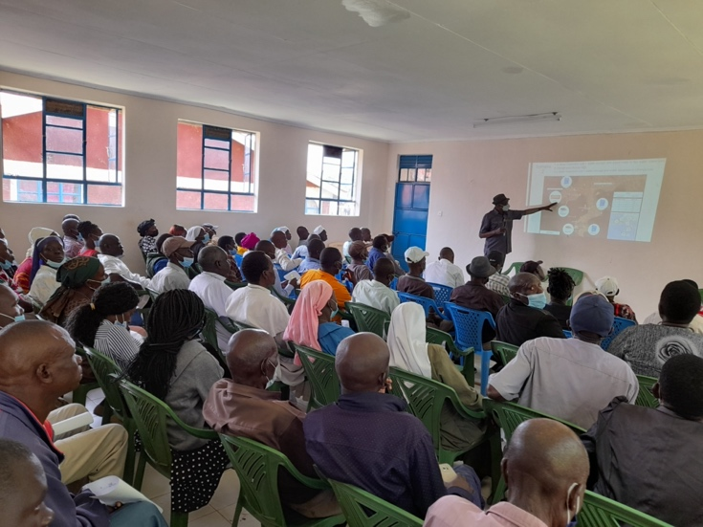 | 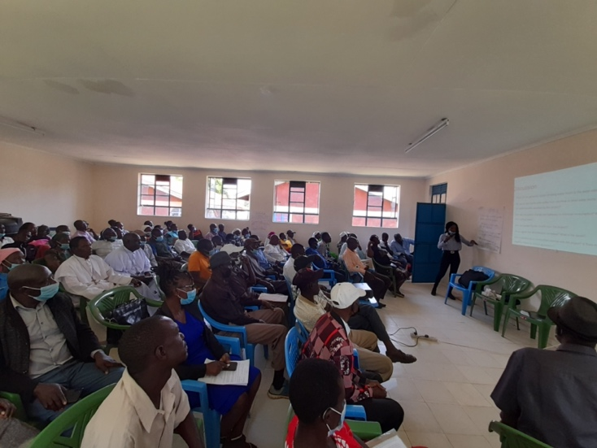
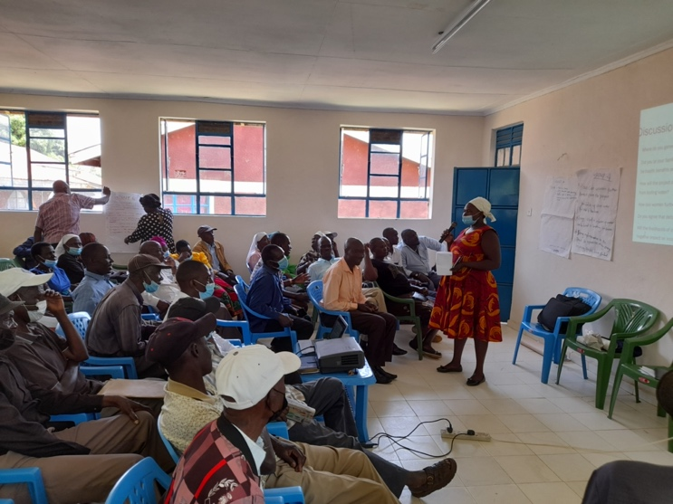 | 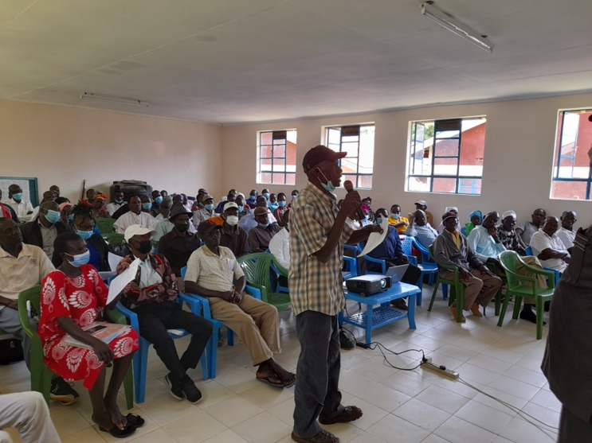
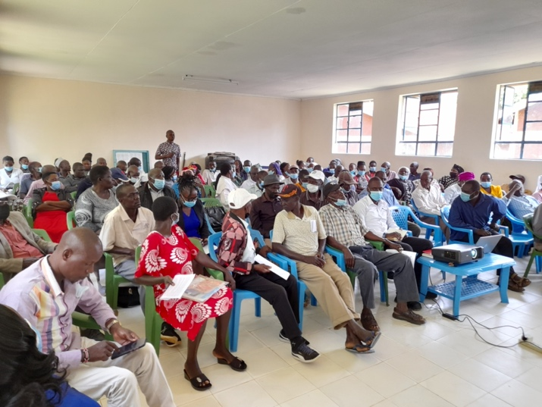 | 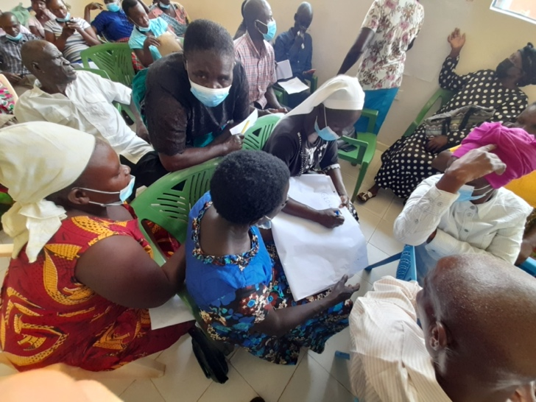
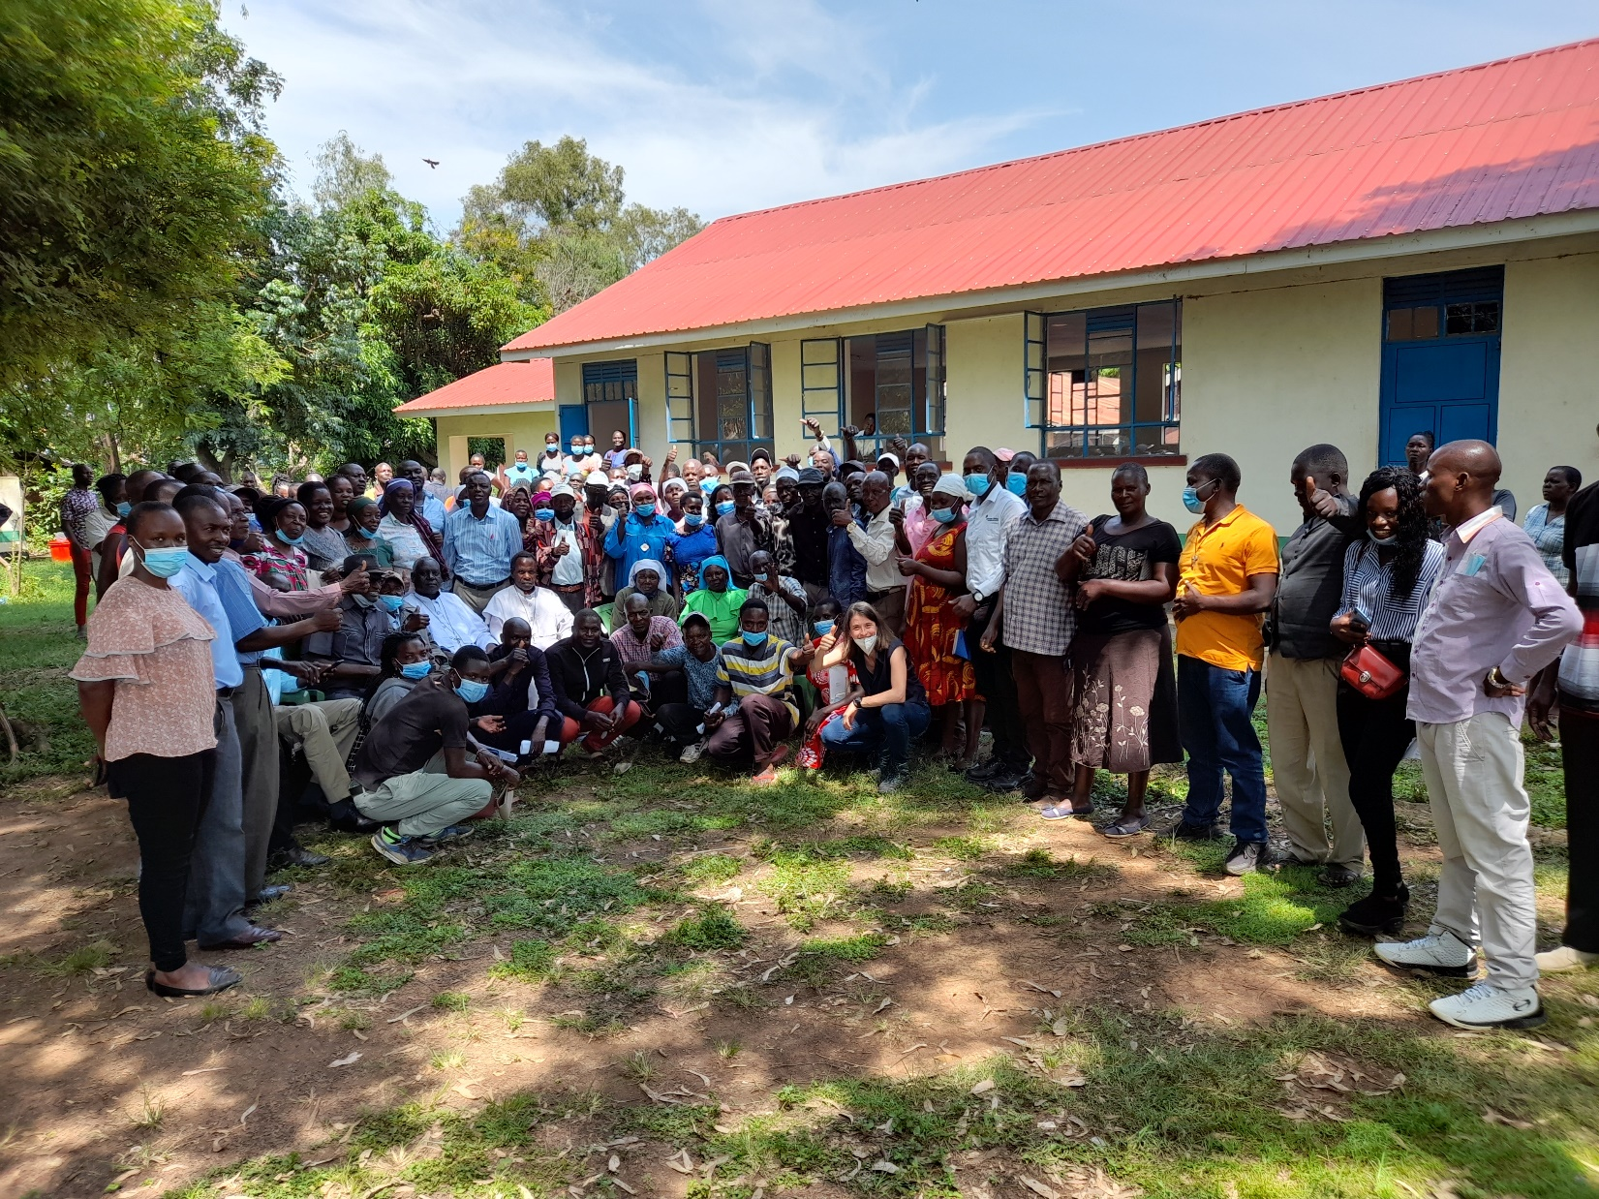

        - Minutes of physical meeting(s)
>>
The meeting took place in Usenge Hall on January 24th 2022 and 96 participants attended. The meeting opened by welcoming all participants and explaining the aim of the meeting. The participants from local community and institutions introduced themselves. The representatives of the project partners also introduced themselves and their roles in the project shortly. All presentations and discussions were interpreted in local language and vice versa by project representatives.

The first presentation was held by Dr. Orodi Odhiambo from local partner Makohaa. He explained general and specific objectives of the project and introduced the project partners in detail. He further gave details of project implementation. The project will be located in Usenge and Uhanya constituencies. Solar powered water treatment plant will purify the water that will be distributed to water kiosks and sold to the local communities. He also mentioned the positive impacts on the life standards of the community and environment. Following questions were received:

Question 1: Will the safe water provided by the project through the water kiosks be for free or will be sold? If sold, which price will be charged to the community members?
Answer: The project partners explained that the water provided through the kiosks will be sold at an affordable price that will be established in accordance with the local authorities and communities. The project partners also explained that the economic resources generated by the sale of the water will be used to maintain the systems and assure proper safety and management, in order to avoid failure.

Question 2: How the kiosk will be operating?
Answer: The kiosks will be digital so that people will buy the water by using prepaid cards by using USSD. The kiosks will have some people from the community who will supervise the security of the kiosks. The kiosks will operate from early morning up to the evening, assuring water provision to the community, 7 days a week, 365 days a year. The management of the water kiosks will be done by the local partner MAKOHAA with the support of the communities.

Question 3: Will there be job opportunities for those currently doing water vending business?
Answer: Still there will be possibility for them to work as water vendors by supporting the people from the community to bring their water from the water kiosks to their houses. Moreover, they could sell the safe water to the nearby villages which are not covered by the project intervention. Lastly, some of them could also be included in the project as supervisors of the security of the water kiosks.

Question 4: What about the areas which are not covered by the project?
Answer: The project partners, with the support of the Member of County Assembly Mr. Willis Osoo, explained that to start the project will cover the areas in Usenge and Uhanya constituencies but there is possibility of replicability of the project in the future as long as this first project is successful and the water systems and kiosks well managed.

Second presentation was made online by Zeynep Pinar Ozturk, who further discussed climate change, carbon finance and the contributions of the project to sustainable development goals. She introduced Gold Standard Foundation with the core principles and explained how the project will reduce GHG emissions to achieve certification. She explained that the carbon finance would be used to implement the project and management of monitoring activities, assuring the price of water remain affordable for communities, carrying out hygiene campaigns and enhancing the reach of project to wider range of households. The participants to the meeting are informed that an agreement would be signed with the representatives of the communities for transferring the ownership of the carbon credits to project implementers. In return, the project implementers commit to do the necessary expenditures to supply accessible and drinkable water to the people.

Then, the contribution of the project to each sustainable development goals clarified and then the participants are asked to discuss the SDG contributions of the project in groups. A couple of questions were asked to trigger the discussion and share comments in groups. Following comments have been received:

Comment 1:
Drinking water is supplied from lake, rivers and some privately owned wells. Lake and river water is polluted. The water from wells is safe but not enough for the whole community.

Comment 2:
We often suffer from water-borne diseases; such as typhoid. With the safe water provided by the project, we will save money from health treatments. The availability of clean water will improve our health and labor force available during the year. This will further improve the availability of food supply.

Comment 3:
The amount of fuelwood or charcoal consumption will reduce because we will not need to boil the water to drink. We will save time spent on boiling water as well.

Comment 4:
Women will have easier access to clean water for use in their homes. The time and energy spent for collecting water can be used for other activities that are constructive for themselves and their families as well as the community. Job opportunities may be available for women during the implementation of the project.

Comment 5:
Deforestation is increasing due to production of charcoal, use of firewood for cooking and water boiling. Deforestation is linked with the high dependance to firewood for energy needs of the community.

Comment 6:
We believe that the project will improve our lives in many ways.
The project will prevent water- borne diseases by providing clean water and we can save the money spent on medication.
Women will have more time to attend their families and community matters.
The children will not miss school days due to the health problems and their education will not be interrupted.
The community will be empowered and job opportunities will be provided.
Those who currently do water vending may take part in management of the infrastructures.

After the discussion, the meeting continued with safeguarding principles assessment and discussion of mitigation and monitoring plans. It is explained that the project will be implemented in line with all health and safety measures for workers. No additional comments are received from the participants.

The discussion is followed by the introduction of continuous input/ grievance mechanism options. The process book is decided to be placed in the local villages chiefs’ offices.

Before closing remarks, the participants were asked to fill down the evaluation forms. They were also informed that all project documents would be accessible on web and another feedback round would be run for two months as a part of the project certification. It is also stated that all participants to the live meeting would be informed about the start of the second feedback round.
          - Minutes of other consultations
There was huge interest to the project and approximately 100 participants attended the stakeholder consultation meeting. There were request and comments from stakeholder to expand the project to cover Yimbo region as a whole. During those interactions, it was understood that a water supply and treatment system was already established but was not operational. Therefore, the project representative reached out the PENWA, the organization responsible of operating the system and organized a complementary meeting with them and local government authorities on 29th January 2022. The following people were present at the meeting:
- Hon. Ghidion Ochianda: Member of Parlament, representative of Bondo Constituency
- Francis Othiato: Member of County Assembly of Siaya, representative of East Yimbo Ward
- Willis Osoyo: Member of County Assembly of Siaya, representative of West Yimbo Ward
- Moses Odhiey: Bondo Subcounty water officer
- Noah Albert: Vice-Chair of Penwa CBO
- Consolata Athis Anyango: Treasurer of Penwa CBO
- Samson Aloo: Secretary of Penwa CBO
- Sos Peter Othiero: assistant secretary of Penwea CBO
- Water Acumo: member of Penwa CBO
- Paul Onyango: Penwa Committee member, representative of youth
- George Othiero: Penwa Committee member, representative of central Yimbo
- Adam Odhiambo: representative of Makohaa
- Valentina Quaranta: representative of OffgridSun
The meeting started with a brief introduction of water supply and treatment system which was built Action Aid between 2007 and 2011 in East Yimbo. The system was planned to serve both East and West Yimbo. PENWA was founded for the management of the water system after Action Aid handed over the operation. However, the organization could not manage the run the system due to high management costs. A new management was appointed on October 2021 to find solutions to technical and operational problems. Several renovations and maintenance are required to run the system again. A pre-payment system is also needed be engaged for the sustainability of the water services.

Valentina Quaranta introduced the project Maji Safi Maisha Bora, explained the objective and the scope of the project, and the carbon credits mechanism of financing the project to the participants. All the participants, especially the member of parliament, welcomed the proposal of collaboration between the two projects and integration instead of overlapping. The Member of Parliament explained the challenges faced by the management of the system. He added that the people were in need of water as the system, which is supposed to serve both east and west yimbo ward, is not operating due to high running costs and poor management. PENWA explained that with the assignment of the new committee, their aim was to solarize the system and establish smart kiosks to sell water through prepaid digitalized systems. Since the proposed project has similar implementation plans, all the participants agreed not to build a new system in Usenge, rather to improve and upgrade the system which is in place but not operational. Since that the proposed project aims to supply water to Uhanya is also planned by the Siaya County and PENWA, it is agreed that the cooperation of all organization would be beneficial for all parties.

As a result of the meeting, the parties decided to upgrade the existing system with the help of carbon revenue gained by the proposed project. The project partners Offgridsun, Epicenter and Genius Water will undertake the technical work while local partner PENWA will run the system. Makohaa is responsible for capacity building component of the project and will carry out water hygiene campaigns.

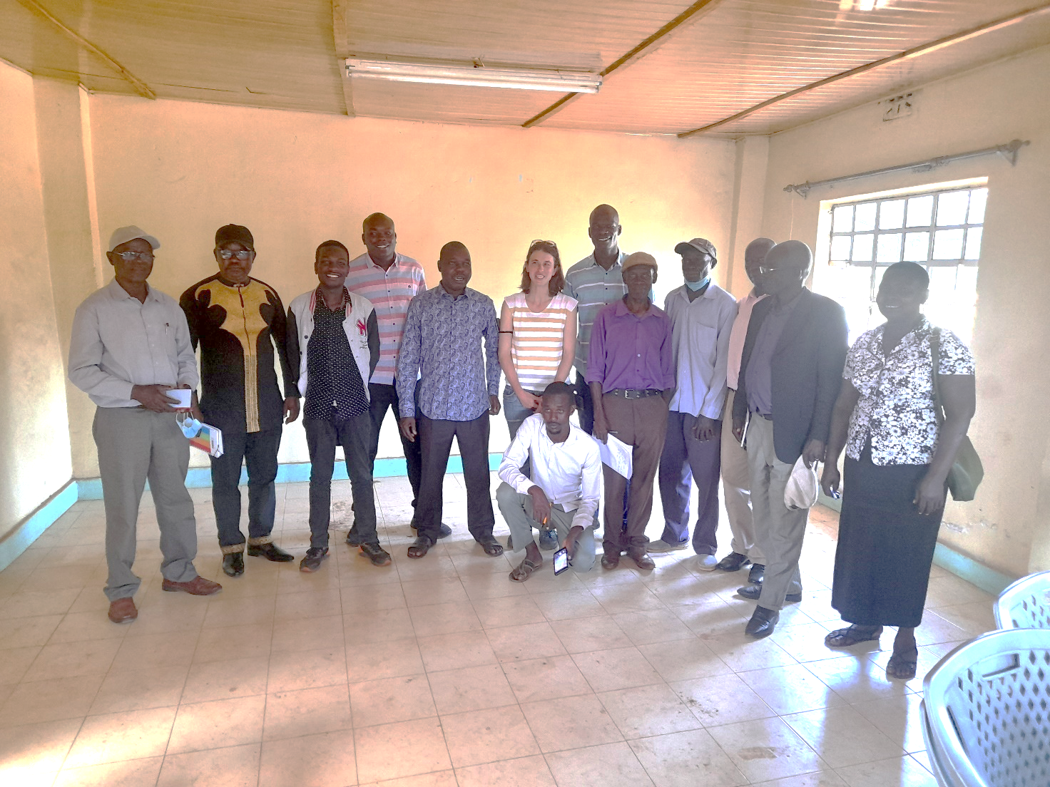
From the left: PENWA member, PENWA Vice Chairperson, Makohaa representative, Member of County Assembly, East Yimbo Ward, Member of Parlament (Bondo Constituency representative), OffgridSun representative, Member of County Assembly (West Yimbo Ward), PENWA Secretary, PENWA Assistant Secretary, PENWA Member, Bondo Subconty Water Officer, PENWA Treasurer, PEWNA Member (down).
        - Assessment of comments from all consultations above

Gender of Stakeholder | Stakeholder  comment | Was comment taken into account (Yes/ No)? | Explanation (Why? How?)
M | Drinking water is supplied from lake, rivers and some privately owned wells. Lake and river water is polluted. The water from wells is safe but not enough for the whole community. | Yes | The project aims to address safe water supply problem in the region.
F | We often suffer from water-borne diseases; such as typhoid. With the safe water provided by the project, we will save money from health treatments. The availability of clean water will improve our health and labor force available during the year. This will further improve the availability of food supply. | Yes | The water supplied by the project will be tested from time to time to assure its microbial quality.
M | The amount of fuelwood or charcoal consumption will reduce because we will not need to boil the water to drink. We will save time spent on boiling water as well. | Yes | The project aims to reduce GHG emissions related with water boiling for drinking purposes. The carbon credits gained will support project implementation and enable the continuation.
F | Women will have easier access to clean water for use in their homes. The time and energy spent for collecting water can be used for other activities that are constructive for themselves and their families as well as the community. Job opportunities may be available for women during the implementation of the project. | Yes | The project will mostly affect the life of women who generally fetches water and boils to purify. The time saved may be used for other economic activities.  Women will be given priority for job opportunities.
M | Deforestation is increasing due to production of charcoal, use of firewood for cooking and water boiling. Deforestation is linked with the high dependance to firewood for energy needs of the community. | Yes | By providing safe water and fuelwood used for boiling will be avoided. This will reduce the pressure of the high demand on forests for firewood.
M | We believe that the project will improve our lives in many ways.  The project will prevent water- borne diseases by providing clean water and we can save the money spent on medication.  Women will have more time to attend their families and community matters.  The children will not miss school days due to the health problems and their education will not be interrupted.  The community will be empowered and job opportunities will be provided.  Those who currently do water vending may take part in management of the infrastructures. | Yes | Most of social benefit mentioned have been considered as the contributions to SDGs.  Money savings from health treatments and the contribution to education are other contributions mentioned by the participants, however; they are hard to monitor.  The water vendors may choose to work for the project or serve the safe water to distant households that are covered under the project’s scope.

          - Evaluation forms (best practice)
The original evaluation forms are provided in Annex.4 separartely.
Name | Gabriel Oketch
Gender – Male/Female: | M
What is your impression of the meeting? | It is so educative
What do you like about the project? | By the end of the project life standards will be raised.
What do you not like about the project? | Nothing
Signature

Name | Collins Avlo
Gender – Male/Female: | M
What is your impression of the meeting? | One of the best water community meetings
What do you like about the project? | It has talked about the health improvement of the communities
What do you not like about the project? | Everything discussed is impressive for the growth of the community
Signature

Name | Alice Auma
Gender – Male/Female: | F
What is your impression of the meeting? | Good teaching and quite motivating
What do you like about the project? | It has talked about the health improvement of the communities  Everything discussed is impressive for the growth of the community
What do you not like about the project?
Signature

Name | John Atito Omenya
Gender – Male/Female: | M
What is your impression of the meeting? | The meeting of today was very good
What do you like about the project? | This project is to improve good health of the people of the area  It is going to create jobs for the people of the area
What do you not like about the project?
Signature

Name | George Atiang
Gender – Male/Female: | M
What is your impression of the meeting? | The meeting is impressive and successful
What do you like about the project? | It will reduce waterborne diseases
What do you not like about the project? | Nothing
Signature

Name | Mathew Oreng
Gender – Male/Female: | M
What is your impression of the meeting? | Very informative, quite engaging and interactive
What do you like about the project? | The project is timely and well targeted
What do you not like about the project? | Might not cover the entire Yimbo but very good for a start.
Signature

Name | Denise Otieno
Gender – Male/Female: | M
What is your impression of the meeting? | It was quite good and motivating
What do you like about the project? | It has several gains in our livelihoods
What do you not like about the project? | All is good.
Signature

Name | Celline Akelo Agwanda
Gender – Male/Female: | F
What is your impression of the meeting? | Very educative
What do you like about the project? | Getting clean, purified and affordable water
What do you not like about the project? | Null and void
Signature

Name | N. Odhiambo
Gender – Male/Female: | M
What is your impression of the meeting? | It has made us interact internally as community and shows about the development that we are soon be achieving.  It has raised awareness on outgoing project
What do you like about the project? | It will create development and employment for the community
What do you not like about the project? | All good
Signature

Name | Zedekia Onyango
Gender – Male/Female: | M
What is your impression of the meeting? | We discuss how we can maintain the environment so the meeting has gone well without any interference.
What do you like about the project? | The thing which I like in this project to come very fast
What do you not like about the project?
Signature

Name | Ascar Adhiambo
Gender – Male/Female: | M
What is your impression of the meeting? | The facilitators were friendly and our opinion are well taken.
What do you like about the project? | The project is going to enable us get clean, safe and affordable water and also walkable distance.
What do you not like about the project? | I thought that we will get water each and every home but that is not going to happen.
Signature

Name | Magana Catherine Akoth
Gender – Male/Female: | F
What is your impression of the meeting? | Free discussion, everyone was open minded.
What do you like about the project? | Creating job opportunities, availability of clean water.
What do you not like about the project? | Time keeping  Flexibility
Signature

Name | Joyce Papertune Atieno
Gender – Male/Female: | F
What is your impression of the meeting? | You are given a chance to say your opinion.
What do you like about the project? | The meeting was free for everybody and you are allowed to speak.  The project has brought good information to us
What do you not like about the project? | Flexibility
Signature

Name | Leo Oching Oduor
Gender – Male/Female: | M
What is your impression of the meeting? | We appreciate the meeting and love the intention of bringing the water for us.
What do you like about the project? | It will reduce deforestation  It will also create some employment  We will drink pure water hence reducing diarrhea
What do you not like about the project? | There is nothing negative I can say about the project.
Signature

Name | Rose A. Ndagwa
Gender – Male/Female: | F
What is your impression of the meeting? | I am happy with this meeting
What do you like about the project? | I like it to change my life
What do you not like about the project? | I would not like it to fail.
Signature

Name | Lazarvo Ogwira
Gender – Male/Female: | M
What is your impression of the meeting? | We appreciate the impact of the meeting hence providing us with water
What do you like about the project? | It creates employment  It is well used to prevent some diseases
What do you not like about the project? | The project is well subjected.  No bad issue to be represented.
Signature

Name | Millicent Okello
Gender – Male/Female: | F
What is your impression of the meeting? | Good
What do you like about the project? | I like it
What do you not like about the project?
Signature

Name | Tom Othoon Ogola
Gender – Male/Female: | M
What is your impression of the meeting? | Interesting and educative
What do you like about the project? | Provision of clean water to the community Yimbo West Ward  Water borne diseases will also be reduced.
What do you not like about the project? | Some of the water vendors will be rendered jobless
Signature

Name | Linet Okoti
Gender – Male/Female: | F
What is your impression of the meeting? | I loved the meeting since access to water has been a serious challenge to us
What do you like about the project? | I am happy about the project since it will bring water to us
What do you not like about the project? | I love the project but I am concerned if I will be allowed  to access it since during the census I was in another meeting and not at home and I was not counted
Signature

Name | Moses Ondiji
Gender – Male/Female: | M
What is your impression of the meeting? | The meeting has been healthy and the project is going to benefit the community so much.
What do you like about the project? | The project will finish the issue of water problem in the area and reduce water borne diseases in the area
What do you not like about the project? | I welcome and support the project.
Signature

Name | Violet Atieno
Gender – Male/Female: | F
What is your impression of the meeting? | Holding a stakeholder meeting was a good idea because it informs the community on what is to be done (project activities)
What do you like about the project? | The project is likely to have positive impacts to the community hence raising their living standards.
What do you not like about the project?
Signature

Name | Gaddy Otieno Onyango
Gender – Male/Female: | M
What is your impression of the meeting? | The meeting will help create employment
What do you like about the project? | It will create job employment  It will reduce diseases like diarrhea.
What do you not like about the project? | The project is well subject to no any issues.
Signature

Name | William Ogera
Gender – Male/Female: | M
What is your impression of the meeting? | The meeting was good since we have always wished to have access of clean water
What do you like about the project? | The project will bring clean water which is something we have always wished for
What do you not like about the project? | I just wish to say thank you for bringing this project to us
Signature

Name | No name stated
Gender – Male/Female:
What is your impression of the meeting? | Impression of the meeting was good and lively
What do you like about the project? | The project will bring good life to the community
What do you not like about the project? | The project should not fail after commencing
Signature

Name | No name stated
Gender – Male/Female:
What is your impression of the meeting? | I learned a lot of new things about water treatment and supply
What do you like about the project? | The safe water and WASH system
What do you not like about the project? | The water will not reach my door/homestead
Signature

Name | No name stated
Gender – Male/Female:
What is your impression of the meeting? | Very positive, it is a good project which will change the livelihood of the community
What do you like about the project?
What do you not like about the project? | Nothing
Signature

Name | No name stated
Gender – Male/Female:
What is your impression of the meeting? | My impression is that we are going to get safe water
What do you like about the project? | The project will reduce air pollution
What do you not like about the project? | The project is up to date. Thanks
Signature

Name | No name stated
Gender – Male/Female:
What is your impression of the meeting? | It is very important on that shall improve our health care in community in general of Usenge communities at all.
What do you like about the project? | The project is a good one. It will bring people around in problem going for way from water pond.
What do you not like about the project?
Signature

Name | No name stated
Gender – Male/Female:
What is your impression of the meeting? | So good
What do you like about the project? | It is very very timely
What do you not like about the project? | Everything is okay
Signature

Name | No name stated
Gender – Male/Female:
What is your impression of the meeting? | Job opportunities
What do you like about the project? | Improving people’s living standard
What do you not like about the project? | Nothing
Signature

Name | No name stated
Gender – Male/Female:
What is your impression of the meeting? | The meeting is quite impressive to the extent that the community is enlightened on climate change globally
What do you like about the project? | The project will bring a lot of development and quite amount of community livelihood
What do you not like about the project? | I don’t like the project fail at all.
Signature

Name | No name stated
Gender – Male/Female:
What is your impression of the meeting? | Good
What do you like about the project? | Will provide safe clean water for drinking  I will not have to boil water for drinking
What do you not like about the project?
Signature

Name | No name stated
Gender – Male/Female:
What is your impression of the meeting? | Good
What do you like about the project? | It will benefit the whole community  It will reduce water diseases
What do you not like about the project? | Nothing
Signature

Name | No name stated
Gender – Male/Female:
What is your impression of the meeting? | It was good and interesting
What do you like about the project? | Ability to access safe and clean water for good health
What do you not like about the project? | Nothing
Signature

Name | No name stated
Gender – Male/Female:
What is your impression of the meeting? | My impression was good and educative
What do you like about the project? | It will change the life of the community health wise.
What do you not like about the project?
Signature

Name | No name stated
Gender – Male/Female:
What is your impression of the meeting? | The meeting was live and interesting
What do you like about the project? | The project is going to improve the quality of lives.
What do you not like about the project?
Signature

Name | No name stated
Gender – Male/Female:
What is your impression of the meeting? | To learn more about the safe water
What do you like about the project? | I like the project. I cannot use firewood
What do you not like about the project? | I cannot like fail the project
Signature

Name | No name stated
Gender – Male/Female:
What is your impression of the meeting? | Impression of the meeting was good
What do you like about the project? | What like is that availability of clean water
What do you not like about the project? | Failure of the project
Signature

Name | No name stated
Gender – Male/Female:
What is your impression of the meeting? | I have learnt a lot concerning water
What do you like about the project? | The project will bring clean water for use
What do you not like about the project? | The water will not be connected directly into my home
Signature

Name | No name stated
Gender – Male/Female:
What is your impression of the meeting? | The meeting was understandable and languages were clear
What do you like about the project? | We will drink clean water and have better lives
What do you not like about the project? | questions were asked that were not relevant to the topic
Signature

        - Summary of alterations based on comments
>>
The stakeholders confirmed that the project will provide net SDG benefits and will not pose any risks towards safeguarding principles. Their general concern about the project was being unsuccessful or interrupted. The water vendors have also been mentioned as group to be negatively affected by the project. The project already considers to provide to the vendors to work for the project.

The project proponents received requests and comments for the expansion of the project to whole Yimbo region. In accordance with those requests, the project particpants got in contavt with PENWA, responsible for operating a water supply and treatment system that is not operational. After a meeting done with the organizaiton and the local authorities, all parties agreed to collaborate to provide safe drinking water to whole Yimbo region.
Please use the table below to report on the methods agreed with stakeholders

CONTINUOUS INPUT / GRIEVANCE MECHANISM
 | Method Chosen (include all known details e.g. location of book, phone, number, identity  of mediator) | Justification of Choice  (best practice)
Continuous Input / Grievance Expression Process Book (mandatory) | The process books will be placed in the local villages chiefs offices | Mandatory
GS Contact (mandatory) | help@goldstandard.org | Mandatory
Telephone access (optional) | For Kenya: 0725 658 150  For Italy:+39 3516142230 | A local number will be available for minor inputs and grievance that require immediate response.
Internet/email access (optional) | projects@offgridsun.com | Email and internet are being used by local and international NGOs.
Nominated Independent Mediator (optional) | No need for a nominated independent mediator is foreseen by the stakeholders. | Optional
Other | No other means has been offered by the stakeholders | Optional

STAKEHOLDER FEEDBACK ROUND

Please check this box if the project is retroactive and has done only 1 consultation with a physical meeting integrated into the SFR.

        - Length of the Feedback Round

Stakeholder Feedback Round |  | Planned | Actual
Start Date | 01.05.2022
End Date | 01.07.2022

        - Summarise how all stakeholders were/will be invited to provide feedback
>>

The stakeholder feedback round will be conducted for 60 days online starting on early May to early July. The draft project design document and stakeholder consultation report will be shared by both email and online at Offgridsun webpage.

All stakeholders invited to the live meeting will also invited to stakeholder feedback round.
        - Summarise Feedback received, including if any changes in project design were made
>>
N/A
Revision History

Version | Date | Remarks
1.1 | 14 October 2020 | Inclusion of Key Project Information  Restructure, new headings and reorder to better match the steps a developer will follow in consultations.  Removal of some non-mandatory template tables (Blind Sustainable Development Assessment). Clarification of best practice steps that are non mandatory processes, clarification of mandatory discussion points. Clarification regarding publishing names and that original evaluation forms (optional) and attendance lists (mandatory) should be separate documents.  Improved clarity on Stakeholder Feedback round section and procedures for retroactive projects  Provision of an accompanying Guide to help the user understand detailed rules and requirements
1.0 | 14 August 2017 | Initial adoption

Annex.1 Invitation Letter

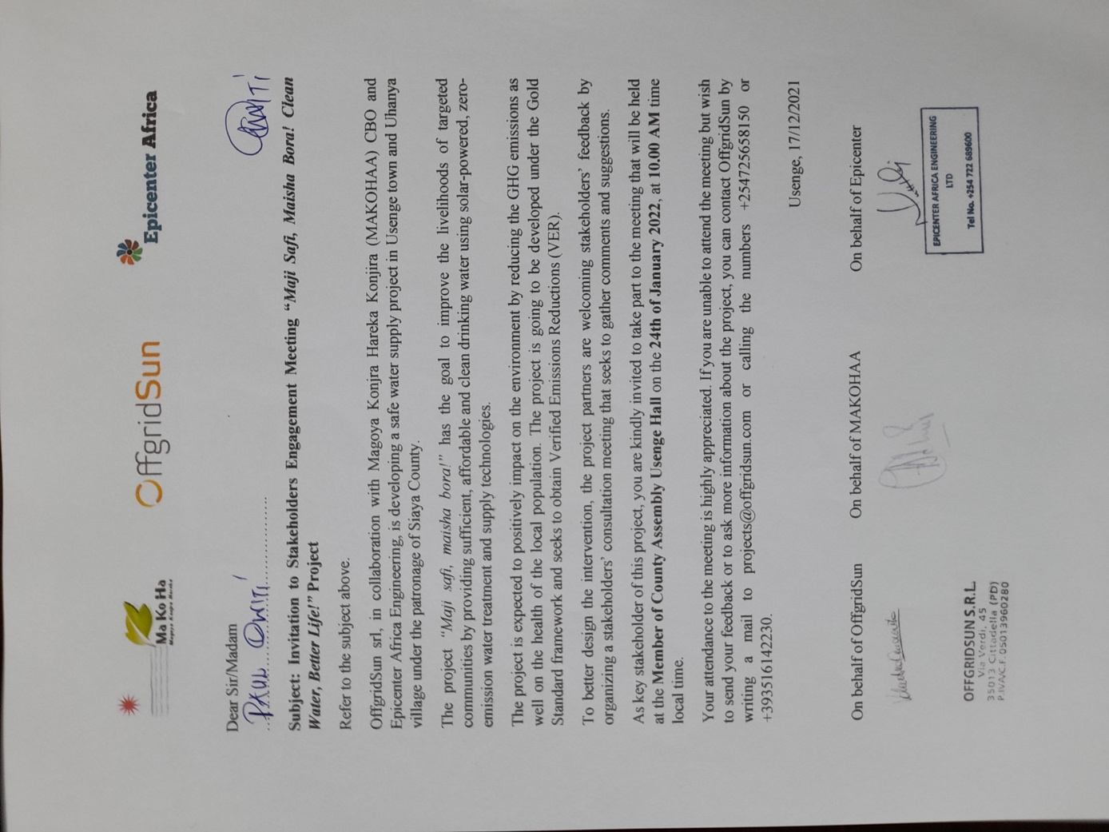

Annex.2. Invitation Email

